**IBM Report (Nalaiya Thiran)**

**IOT based Smart Farming**

**SUBMITTED BY**

VARUN PRASAD. K **(113219041128)**

RAMAKUMAR. B **(113219041093)**

SOMANATH. S **(113219041113)**

LAKSHMI NARAYANAN.VR **(113219041055)**

PAVAN KUMAR. VV **(113219041081)**

**PROPOSED SOLUTION FIT AND ARCHITECTURE**

**Project Design Phase-I**

**Proposed Solution Fit and Architecture**

|  |  |
| --- | --- |
| Date | 23th September 2022 |
| Team ID | PNT2022TMID23529 |
| Project Name | IOT Based Smart Farming |
| Maximum Marks | 2 Marks |

**Proposed Solution Template:**

Project team shall fill the following information in proposed solution template.

|  |  |  |
| --- | --- | --- |
| **S.No.** | **Parameter** | **Description** |
| 1. | Problem Statement (Problem to be  solved) | * The water scarcity problem is solved.  * The animal invading is prohibited.  * Temperature is maintained.  * Humidity is checked. |
| 2. | Idea / Solution description | * Now a days farmers are facing many problems in agriculture, some of the problems to be solved are:  * To minimize the usage of water  The soil temperature and humidity can be detected ,if there is a deviation from the normal circumstance the water will be sprinkled from sprinkler. When once again it meets the normal circumstances. The sprinkler will stop sprinkling the water.  * Animals invading  The PIR sensor is used,in which it detects the motion of the animals or other living beings and it will intimate the farmers by an alarm sound and the minimum electric current is released.  *Temperature  The temperature can be maintained by monitoring. When the temperature is low, heat bulb is used to increase the temperature.When the temperature is high, an outer cover is used to prevent the heat.  *Humidity  The humidity sensor is used to maintain the moisture content in soil. |
| 3. | Novelty / Uniqueness | * Hardware wise  Three tanks are used for collecting rain water. Two tanks are used for present and third tank is used for the future use. |
| 4. | Social Impact / Customer Satisfaction | * The cost for implementation is low.  * It saves time and energy.  * The failures of any physical components can be  easily replaced. |
| 5. | Business Model (Revenue Model) | * Approval from the government.  * Extra new features   1. Animal invading sensor. 2. Water Storage. 3. Life span of the component is increased.   * Simple design in implementation.  * Cost efficiency and affordable.  . |
| 6. | Scalability of the Solution | * It takes 3 to 4 months to finish the project. |

**ARCHITECTURE:**

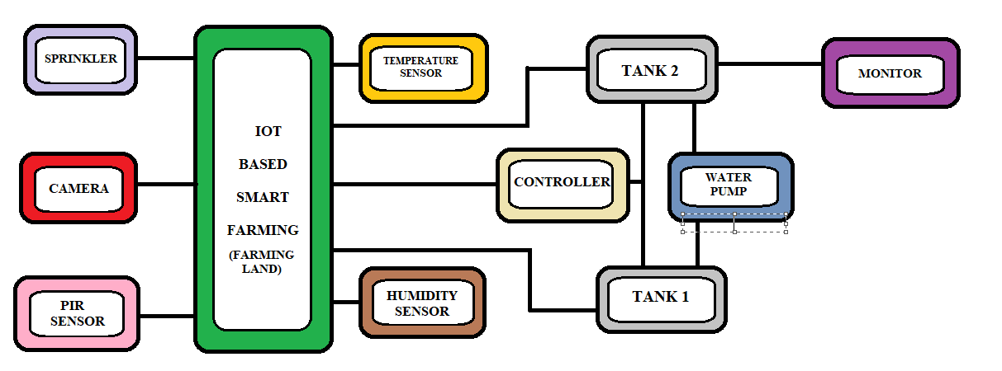

***BLOCK DIAGRAM OF IOT BASED SMART FARMING***

**ALGORITHM / METHODOLOGY:**

**STEP 1:** When the temperature of the soil is increased, the temperature sensor will detect the temperature and water is passed to the land.

**STEP 2:** The water is passed to the land by the help of sprinkler, the sprinkler will sprinkle the water to the land. Moisture level- threshold set  is between 20% and 60%.

Turn ON at 20%.

Turn OFF at 60%.

**STEP 3**: When there any disturbance caused by any living being, the PIR sensor will detect it and intimate the farmer by means of alarm.

**STEP 4**: The plants growth can be monitored by the camera. The camera will send the pic and there is an app implemented in system ,that will detect the plants nutrition level.

Nutrition level of nitrogen is 2-10ppm.

Nutrition level of phosphorous is 25-50ppm.

Nutrition level of potassium is 40-80 ppm.

**STEP 5**: The moisture level in the soil is detected by the humidity sensor.

**STEP 6**: The water level in the tank is detected by the controller.

**STEP 7**: The water pump will pump the water from ground tank to the surface tank.

**STEP 8**: The farmer will monitor the soil fertility and other activities by means of internet connection with a computer.

**STEP 9**: The water is stored at surface used for the present generation.

**STEP 10**: The water stored at the underground is used for the future use.